## Ajax1-Just Updating Div

Here the Older Div data remain Same , but new data is added/Updated with the new Div Data

**ajax1.html**

<!DOCTYPE html>

<html>

<head>

<script src="http://ajax.googleapis.com/ajax/libs/jquery/1.10.2/jquery.min.js">

</script>

<script>

$(document).ready(function(){

  $("button").click(function(){

    $("#div1").load("a.html  #div2");

  });

});

</script>

</head>

<body>

<p id="div1"><h2>Let jQuery AJAX Change This Text Iam From OUE PAGE</h2></p>

<button>Get External Content</button>

</body>

</html>

**a.html**

<div id="div2">THIS Comtent form ajax</div>

HELLO HELLO

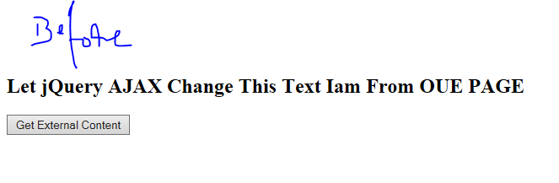

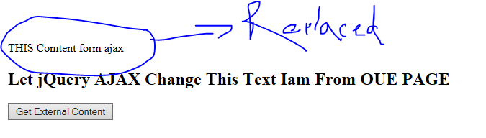

## Ajax2-Replacing whole Page

Here the Whole Page will Replace. It gives Clumsy / Inappropriate Web page

**ajax2.html**

<!DOCTYPE html>

<html>

<head>

<script src="http://ajax.googleapis.com/ajax/libs/jquery/1.10.2/jquery.min.js">

</script>

<script>

$(document).ready(function(){

  $("button").click(function(){

    $.ajax({url:"a.html  #div2",success:function(result){

      $("#div1").html(result);

    }});

  });

});

</script>

</head>

<body>

<div id="div1"><h2>Let jQuery AJAX Change This Text</h2>

<button>Get External Content</button>

</div>

</body>

</html>



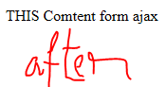

## Ajax3-Just Updating Div – In Struts 2

<!-- AJAX START -->

<script>

$(document).ready(function(){

$("#nxt").click(function(){

alert('Ajax start');

$("#div1").load("design1.action #gb"); 🡪 This Div Data Updated with previous one

});

});

</script>

<!-- AJAX END -->

## Ajax4-Relacing Whole Page – In Struts 2

<script>

$(document).ready(**function**(){

$("#nxt").click(**function**(){

alert('DIV Strtred');

$.ajax({url:"design1.action #gb", **🡪 If u put Div It Won’t Workout**

success:**function**(result){

$("#div1").html(result);

}});

});

});

</script>

## Ajax5-Relacing Specific DIV – In Struts 2

<script>

$(document).ready(**function**(){

$("#nxt").click(**function**(){

alert('DIV Strtred');

$.ajax({url:"design1.action #gb",

success:**function**(result){

**var** aa = $("#div1").load("design1.action #gb"); 🡪 **U have write Separate function for Replacing Specific DIV**

$("#div1").html(aa);

}});

});

});

</script>

<script>

$(document).ready(**function**(){

$("#nxt").click(**function**(){

alert('DIV Strtred');

$.ajax({url:"design1.action #gb",

success:**function**(result){

**var** aa = $("#div1").load("design1.action #gb");

$("#div1").html(aa);

}});

});

});

</script>